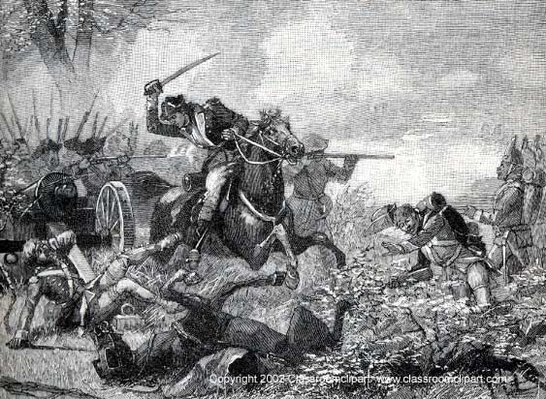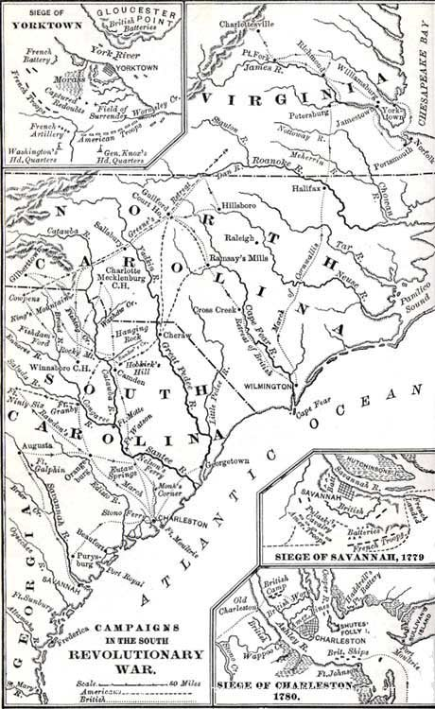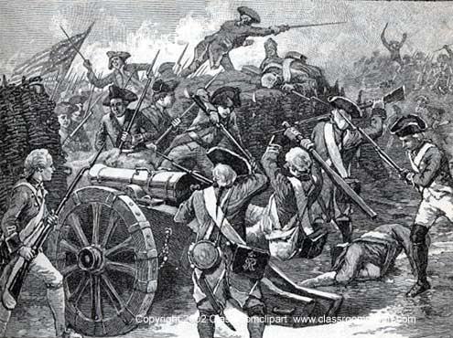

Revolutionary War Roundtable of the Backcountry

What is the Revolutionary War Roundtable of the Backcountry? While there are a number of organizations around the region with a primary interest in Revolutionary War history, this organization is new, having been organized in the summer of 2007 by fifty individuals who share an interest is this and related topics. Our typical meeting will occur four or five time a year and normally have a speaker, discussion or other program. The organization has no agenda and promotes no single viewpoint. Programs will be wide-ranging and focused on any topics pertaining to this period of history as they might relate to the Revolution. Membership is open to anyone regardless of race, creed or sex.

The Backcountry name signifies this region of South Carolina and North Carolina where many decisive engagements of the Revolutionary War were fought and won in the final stages of the war as it moved toward its conclusion at Yorktown. Anyone with an interest in this topic or this period of history is welcome to participate.

The main goal of the organization is preservation of the Revolutionary War the heritage and battlefields in this region of the Carolinas. Roundtable activities will seek to create awareness, leading to appreciation and understanding and thus activating a passion for preserving this history and its remaining sites.

As informed advocates, Roundtable members will be called upon from time to time to take an active role in protecting, preserving and promoting significant sites through the avenues of fundraising, political awareness and public visibility.

Membership Application
Information provided will be used for membership files only.

Name: _______________________________________________________________________________________

Mailing address: ______________________________________________________________________________

City: ___________________________________________State: _______________Zip: _____________________

Home phone: _______________________Office phone: _______________________ Cell: __________________

Fax: ___________________________________________Email: _______________________________________

Membership fee: $25.00 per person per calendar year. Please make checks payable to Revolutionary War Roundtable of the Backcountry.

Return completed application & membership fee to: Charlie Gray, Director of Continuing Education, Wofford College, 429 North Church Street, Spartanburg, SC 29302.

